***Assignment-4***

|  |  |
| --- | --- |
| **Project Domain** | Cloud Application Development |
| **Project Title** | News Tracker Application |
| **Team ID** | PNT2022TMID40746 |
| **Name** | INDUMATHI K |
| **Roll No** | 611019104007 |
| **Date** | 19th Sept 2022 |

**Questions:**

* Program 1: Write a program to test a given number is prime or not.
* Program 2: Write a program to generate odd numbers from m to n using while loop
* Program 3: Write a python program to display prime number series up to given number
* Program 4: Write a python program to generate Fibonacci series

**Answers:**

**Program 1:** Write a program to test a given number is prime or not.

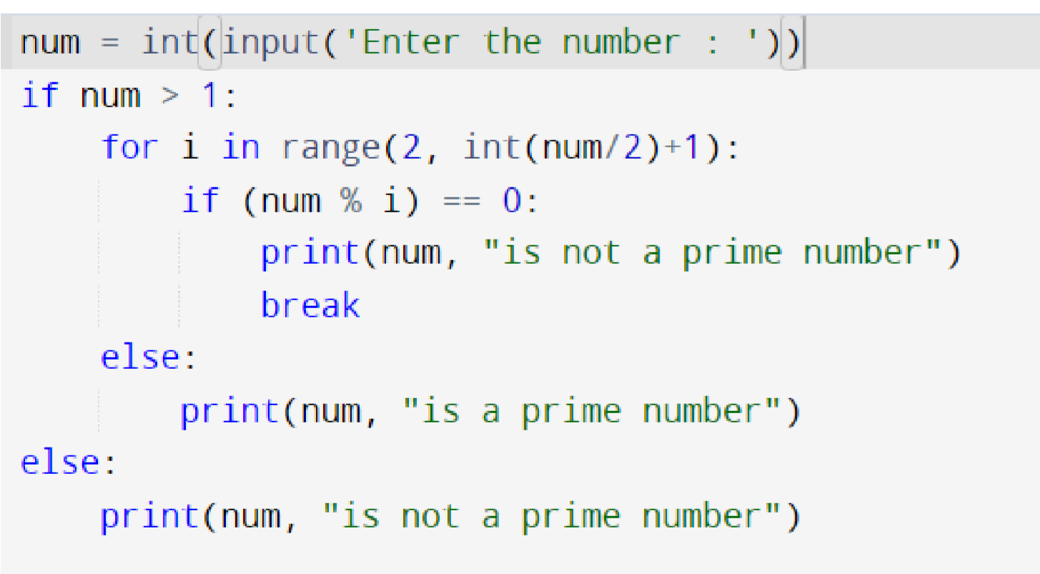

Enter a number:10

10 is not a prime number.

**Program 2:** Write a program to generate odd numbers from m to n using while loop

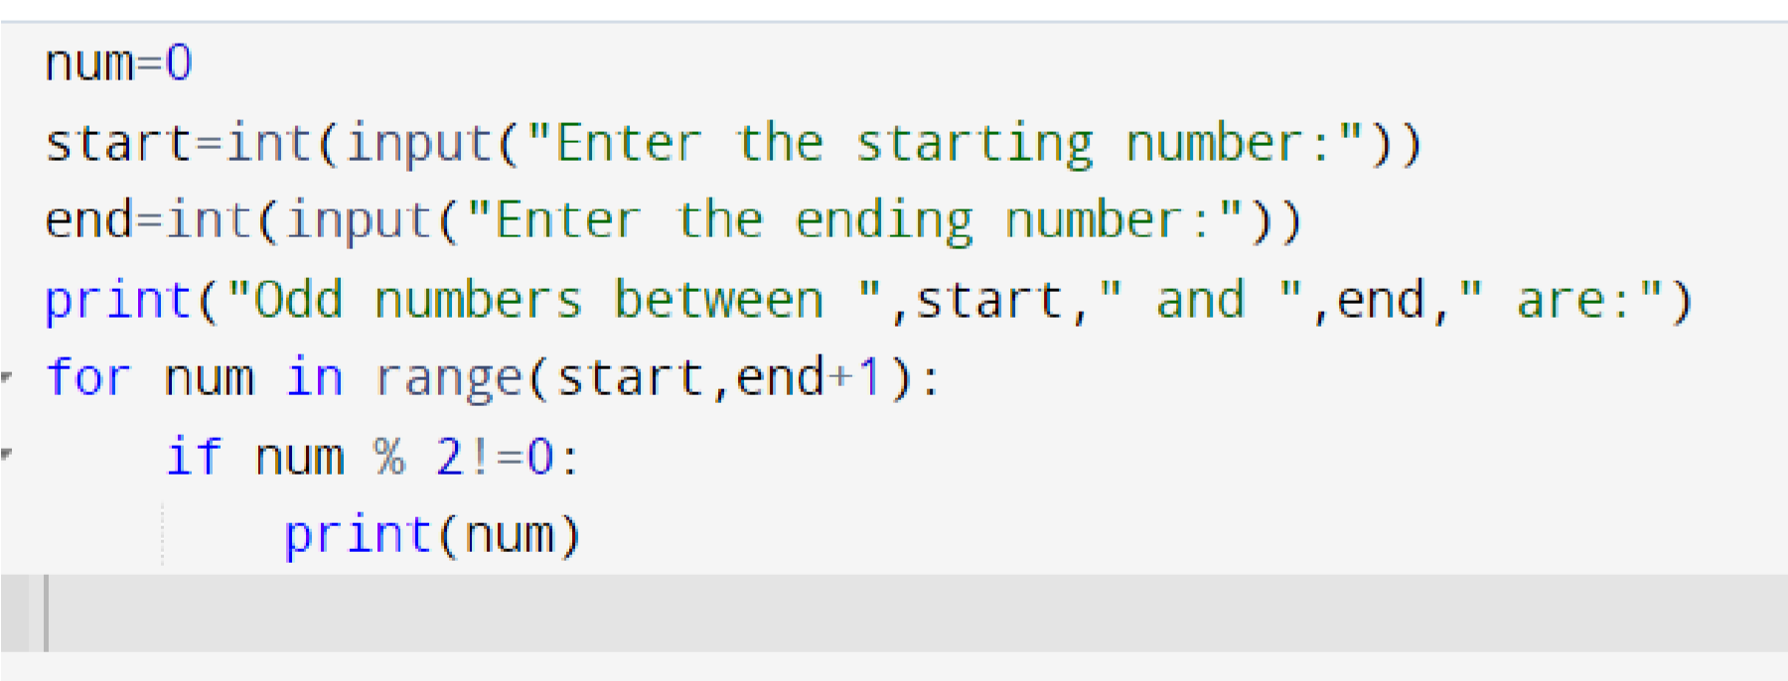

Enter the starting number:1

Enter the ending number:5

Odd numbers between 1 and 5 are:

1

3

5

**Program 3:** Write a python program to display prime number series up to given number

|  |
| --- |
| *#Display prime number series up to given number* **def** prime(num): **for** i **in** range(2,num): **if** num**%i**==0:  **return** **False** **return** **True**  number **=** int(input("Enter a number upto which the series of prime numbers to be displayed: ")) **for** i **in** range(2,number**+**1): **if**(prime(i)):  print("\nThe given number ",i," is prime.") **else**:  print("\nThe given number ",i," is not a prime.") |

Enter a number upto which the series of prime numbers to be displayed:10 The given number 2 is prime.

The given number 3 is prime.

The given number 4 is not a prime.

The given number 5 is prime.

The given number 6 is not a prime.

The given number 7 is prime.

The given number 8 is not a prime.

The given number 9 is not a prime.

The given number 10 is not a prime.

**Program 4:** Write a python program to generate Fibonacci series

|  |
| --- |
| *#Generate fibonacci series* n1**=**0 n2**=**1 n3**=**1 number**=**int(input("Enter the length of Fibonacci series:")) print(n1) print(n2) print(n3) **for** i **in** range(number**-**3):  n1**=**n2 n2**=**n3 n3**=**n1**+**n2 print(n3) |

Enter the length of fibonacci series:6

0

1

1

2

3

5